UNIVERSITY OF ENGINEERING & TECHNOLOGY, MARDAN
Department of Computer Science

COAL LAB REPORT

Student Name | Asim Ayaz
Registration No. | 25MDBCS804
Section | A
Semester | 3rd
Course | Assembly Language
Lab No. | 06
Teacher | Sir Saboor

Task 1
Print array value at index 2
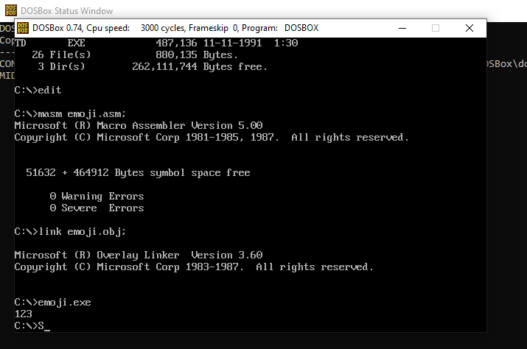

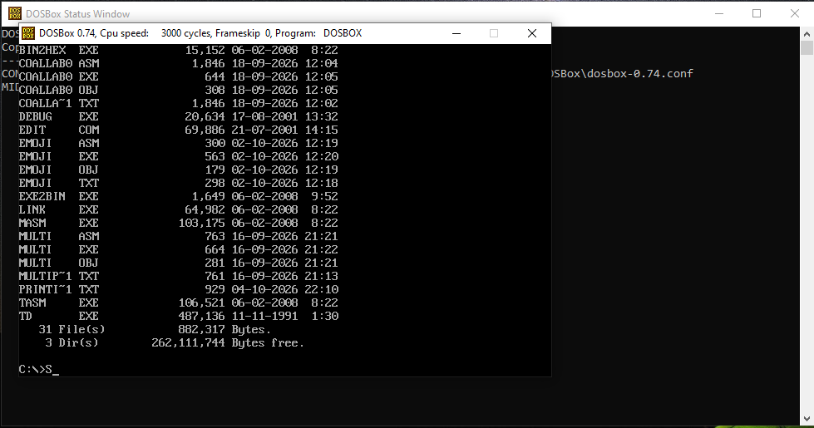

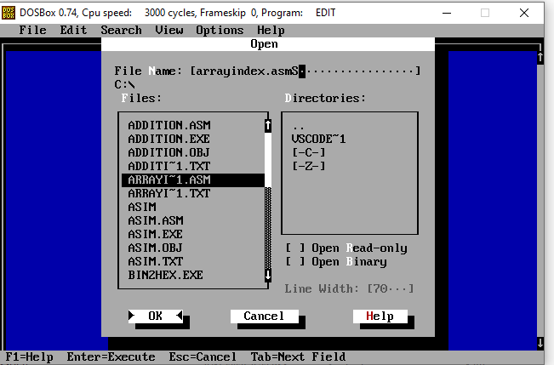

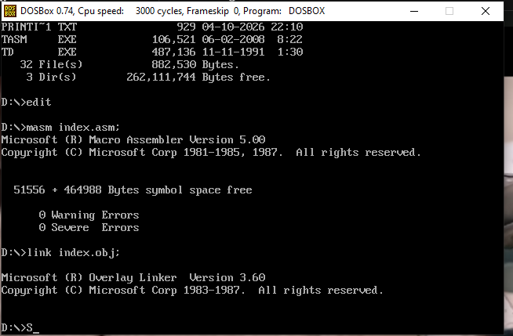
Task 1
Using two different types of arrays and printing their values
I have used:
- BYTE array
- WORD array

